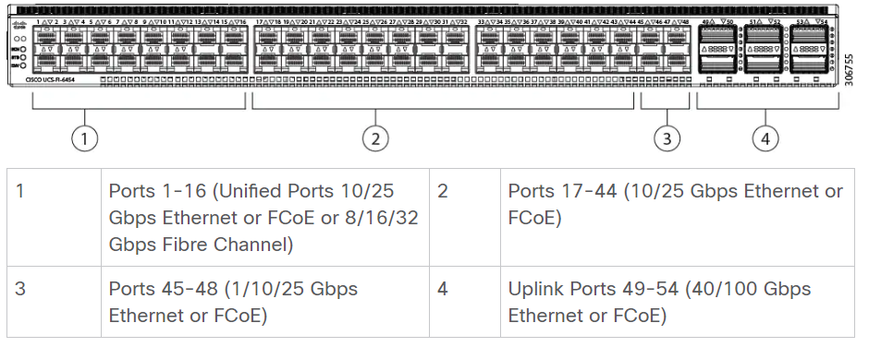

Cisco UCS 6454 Fabric Interconnect ports

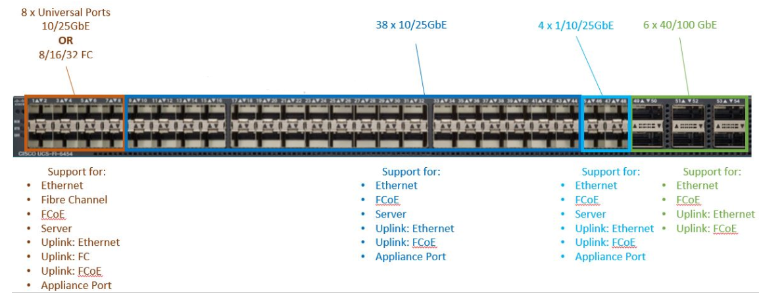

Cisco UCS 6454 Fabric Interconnect (front view)

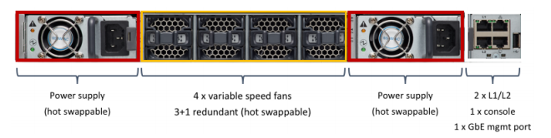

Ports on the Cisco UCS 6454 Fabric Interconnect

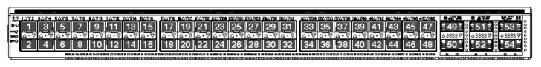

Port capabilities for the Cisco UCS 6400 Series Fabric Interconnects

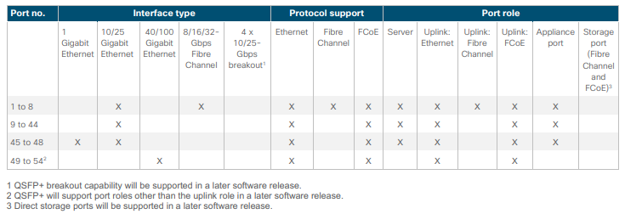

|  |  |
| --- | --- |
|  |  |
| **SFP-25G-AOC1M** | 25GBASE active optical SFP28 cable, 1M |
| **SFP-25G-AOC2M** | 25GBASE active optical SFP28 cable, 2M |
| **SFP-25G-AOC3M** | 25GBASE active optical SFP28 cable, 3M |
| **SFP-25G-AOC5M** | 25GBASE active optical SFP28 cable, 5M |
| **SFP-25G-AOC10M** | 25GBASE active optical SFP28 cable, 10M |
| **QSFP-H40G-AOC1M** | 40GBASE active optical cable, 1M |
| **QSFP-H40G-AOC2M** | 40GBASE active optical cable, 2M |
| **QSFP-H40G-AOC3M** | 40GBASE active optical cable, 3M |
| **QSFP-H40G-AOC5M** | 40GBASE active optical cable, 5M |
| **QSFP-H40G-AOC10M** | 40GBASE active optical cable, 10M |
| **QSFP-4x10G-AOC1M** | 40GBASE active optical QSFP to 4SFP breakout cable, 1M |
| **QSFP-4x10G-AOC1M** | 40GBASE active optical QSFP to 4SFP breakout cable, 1M |
| **QSFP-4x10G-AOC3M** | 40GBASE active optical QSFP to 4SFP breakout cable, 1M |
| **QSFP-4x10G-AOC5M** | 40GBASE active optical QSFP to 4SFP breakout cable, 1M |
| **QSFP-4x10G-AOC7M** | 40GBASE active optical QSFP to 4SFP breakout cable, 1M |
| **QSFP-4x10G-AOC10M** | 40GBASE active optical QSFP to 4SFP breakout cable, 1M |
|  |  |